**Name:** Khaled Soudy Shaker Abdel-Hafez

**B.N:** 313

**Topic:** Programming Languages

**Github-link:**

**Github-page:**

**Application brief**

The first programming language predates the computer by over 125 years. Programming languages first appeared as holes placed strategically on punch cards. These punch cards were fed into the Jacquard Looms and player pianos of the early 1800s to control a sequence of operations and created various patterns in the textiles being created. By simply changing out the cards, the operator of the loom could change the pattern on the textile. This similarity to the early 5.25 and 3.5 inch floppy disks is uncanny.

The first computer program was created by Charles Babbage in the early 19th century to run his conceptual Analytical Engine. The Analytical Engine would be able to calculate logarithms and trigonometric functions using his computer program. His original ideas, combined with various mathematical works throughout the late 19th century and early 20th century, were used by Alan M. Turing in his Turing Machines. These machines were conceptualized in the late 1930s and they worked by manipulating various symbols written on a tape. These concepts gave birth to the ideas of computer memory, automated machines, and the basic working of the modern day CPU. The last of the primitive programming languages was used in the famous ENIAC and UNIVAC computers of the late 1940s and early 50s.

Before 1954 almost all programming was done in assembly language. Modern structured programming languages first appeared in the computers of the 1950s and 60s. The initial modern programming languages FORTRAN, LISP, ALGOL, and COBOL became the basis of the computing world in the middle of the 20th century, and many variations of these languages spawned a multitude of new languages. Modified versions or FORTRAN, LISP, ALGOL and COBOL are still used in 21st century machines. As computers became more efficient and accessible to the public, programming languages were forced to match the increasing complexities associated with the vast increase of technology until the early 1970s.

The 1970s brought forth the concept of object-oriented programming. Object oriented programming began using data structures to create computer programs. A multitude of the programming languages developed after this period, incorporated object oriented programming into their basic ideas. Another huge accomplishment during the 70s was the creation of the C programming language. C or some variation of C is arguably the most widely used programming language in the world in 2010.

The Internet boom of the 90s gave birth to many of the languages used by programmers today. Scripting languages such as Apple-script, Java-script, and Python were born in this era, and paved the way for many other programming languages used for the virtual world of the web. Programming languages are constantly being created, updated, and used. There are currently tens of thousands of programming languages in the world. This is not surprising, because of our dependence on technology and accessibility of powerful computers, designers have free reign to create any language they deem fit to solve any problem. Languages may be created for various reasons ranging from calculating salaries for a corporation to computing the grades of college students.

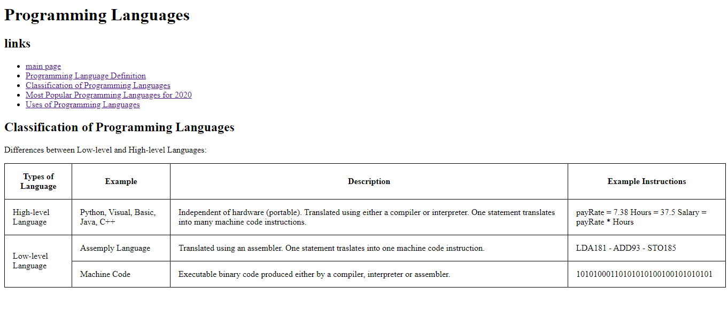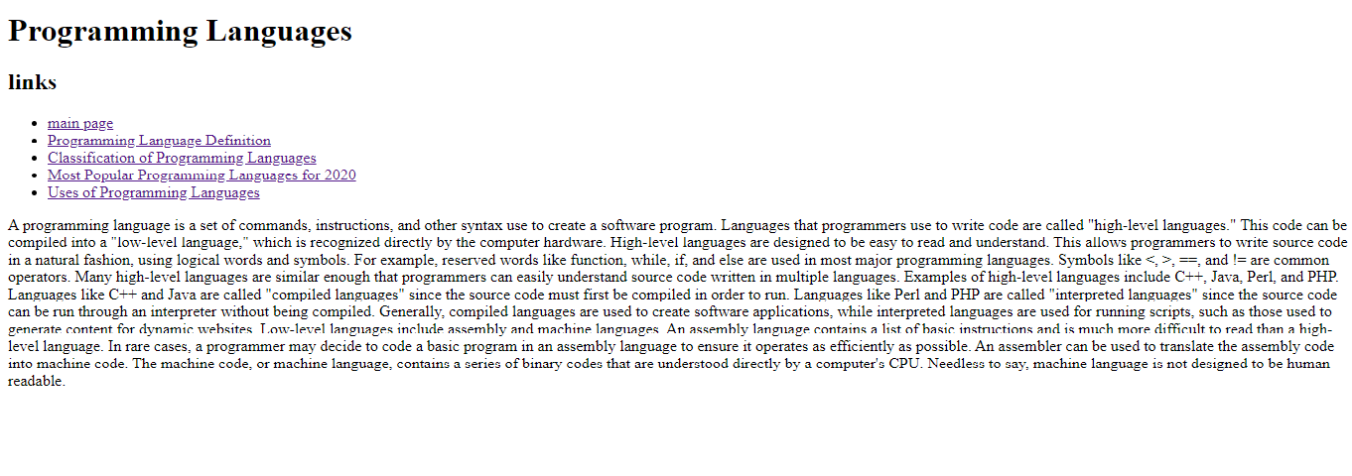**Screenshots**

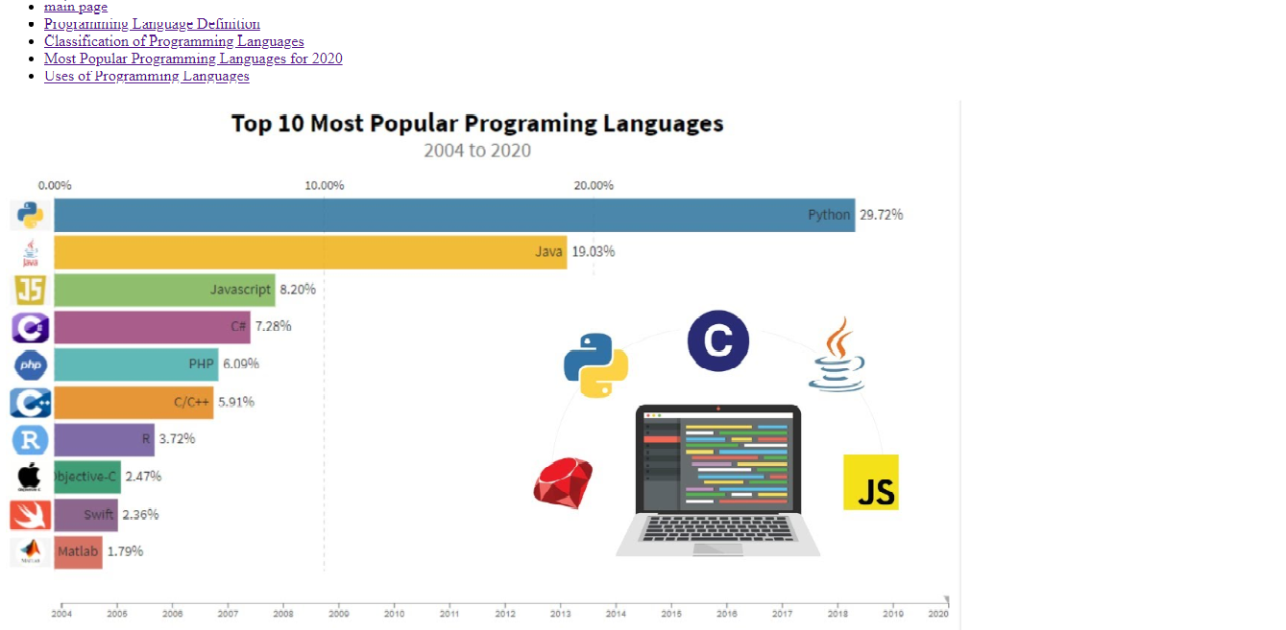

**Source Code**

